**Exercise 3: Stored Procedures**

**Scenario 1:** The bank needs to process monthly interest for all savings accounts.

**Question:** Write a stored procedure **ProcessMonthlyInterest** that calculates and updates the balance of all savings accounts by applying an interest rate of 1% to the current balance.

**Program:**

CREATE OR REPLACE PROCEDURE ProcessMonthlyInterest IS

BEGIN

  UPDATE Accounts

  SET Balance = Balance + (Balance * 0.01)

  WHERE UPPER(AccountType) = 'SAVINGS';

  COMMIT;

  DBMS_OUTPUT.PUT_LINE('Monthly interest processed for all savings accounts.');

END;

/

**Output:** 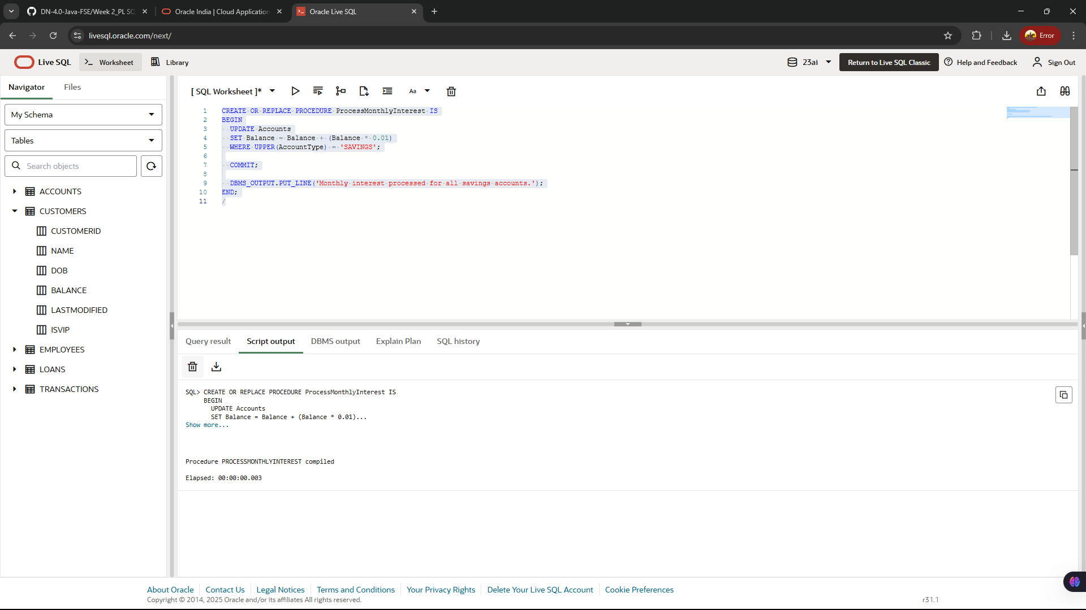

**To Call:**

SET SERVEROUTPUT ON;

BEGIN

ProcessMonthlyInterest;

END;

/

**Scenario 2:** The bank wants to implement a bonus scheme for employees based on their performance.

* + **Question:** Write a stored procedure **UpdateEmployeeBonus** that updates the salary of employees in a given department by adding a bonus percentage passed as a parameter.

**Program:**

CREATE OR REPLACE PROCEDURE UpdateEmployeeBonus (

  p_department IN VARCHAR2,

  p_bonus_percent IN NUMBER

) IS

BEGIN

  UPDATE Employees

  SET Salary = Salary + (Salary * (p_bonus_percent / 100))

  WHERE UPPER(Department) = UPPER(p_department);

  COMMIT;

  DBMS_OUTPUT.PUT_LINE('Bonus of ' || p_bonus_percent || '% applied to department: ' || p_department);

END;

/

**Output:**

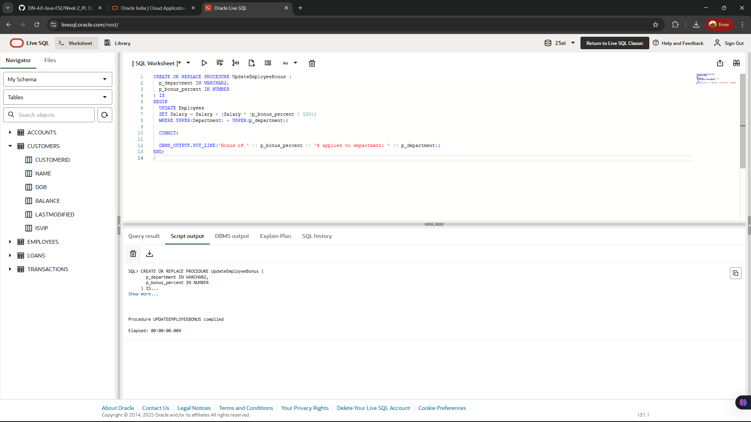

**To Call:**

SET SERVEROUTPUT ON;

BEGIN

-- Apply 15% bonus to all employees in the 'Finance' department

UpdateEmployeeBonus('Finance', 15);

END;

/

**Scenario 3:** Customers should be able to transfer funds between their accounts.

* + **Question:** Write a stored procedure **TransferFunds** that transfers a specified amount from one account to another, checking that the source account has sufficient balance before making the transfer.

**Program:**

CREATE OR REPLACE PROCEDURE TransferFunds (

  p_source_account_id      IN NUMBER,

  p_destination_account_id IN NUMBER,

  p_amount                 IN NUMBER

) IS

  v_source_balance NUMBER;

BEGIN

  SELECT Balance

  INTO v_source_balance

  FROM Accounts

  WHERE AccountID = p_source_account_id

  FOR UPDATE;

  IF v_source_balance < p_amount THEN

    RAISE_APPLICATION_ERROR(-20001, 'Insufficient balance in source account.');

  END IF;

  UPDATE Accounts

  SET Balance = Balance - p_amount

  WHERE AccountID = p_source_account_id;

  UPDATE Accounts

  SET Balance = Balance + p_amount

  WHERE AccountID = p_destination_account_id;

  COMMIT;

  DBMS_OUTPUT.PUT_LINE('Transferred ' || p_amount ||

                       ' from Account ' || p_source_account_id ||

                       ' to Account ' || p_destination_account_id);

EXCEPTION

  WHEN NO_DATA_FOUND THEN

    RAISE_APPLICATION_ERROR(-20002, 'One or both account IDs are invalid.');

  WHEN OTHERS THEN

    ROLLBACK;

    RAISE;

END;

**Output:**

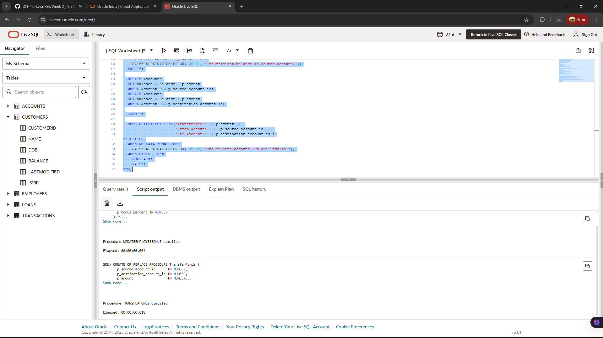

**To Call:**

SET SERVEROUTPUT ON;

BEGIN

-- Transfer ₹500 from account 101 to account 202

TransferFunds(101, 202, 500);

END;

/